**Smyrnov Pavlo**

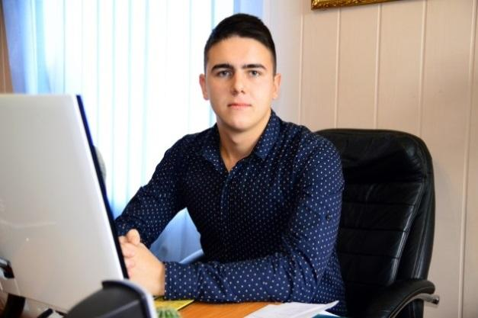  
  
E-mail : smirnov.pavelbrd@gmail.com

Phone: +38 066 980 12 08

Skype – live:.cid.276e1ef124d49818

Marital Status: Married

Residence: Ukraine

Date of Birth: 10.08.1997  
  
**Education**

2014 – 2018 - Berdyansk State Pedagogical University; Faculty of Philology and Social Communications; Department of Foreign Languages. Specialty: English teacher.

12.2019 - Received a master's degree (English Teacher).

**Professional experience**

* Since 01.2023 – back to copywriting
* 03.2022-12.2022 – worked on the River Cruise Ship
* 10.2016-03.2022 –English copywriter/proofreader (IT, gambling, betting)
* 05.2016-09.2016 – Worked in the USA (Work and Travel)

**Additional Information**

* English – fluent
* PC skills at the level of a confident user (Microsoft office, Photoshop)
* Writing articles of various types

**Key Skills**

* Stress resistance
* The desire to work and conquer new peaks
* Ability to work with objections

**Languages:**

* English – fluent;
* Ukrainian – fluent;
* Russian – fluent;
* Bulgarian – pre-intermediate.

Samples of my articles:

* <https://docs.google.com/document/d/1trLSmKXQu44072rn8TklGad2daPeUifZK3kK7JqQtjI/edit?usp=sharing>
* <https://docs.google.com/document/d/1uQSBI1JE8Qcy8Tfi8OfFXWyPsHD_o7LiPulM3oFeD0k/edit?usp=sharing>
* <https://docs.google.com/document/d/1tIOMSRiM3r0p7XhALX_hoieKZDuwjjQ_nyC3BvOOREg/edit?usp=sharing>
* <https://docs.google.com/document/d/1SVgGAPP_zJjhKQfdZLVaFUtjlzq1btE3efrkV0WVquk/edit?usp=sharing>
* <https://docs.google.com/document/d/1fduYwBegRV10utRFsTibhj7EpbszEInNhZV90tMwBms/edit?usp=sharing>